Taw Valley Facilitation Group Annual Report 2016/17

Background

The Taw Valley Facilitation Group is jointly managed by North Devon Biosphere and Westcountry Rivers Trust and has been running since September 2016. Before the start of the project there were farmers’ meetings and discussions to explain the benefits of the project. The first of these meetings was in Chulmleigh in February 2016 and subsequently 68 farmers signed up to the group.
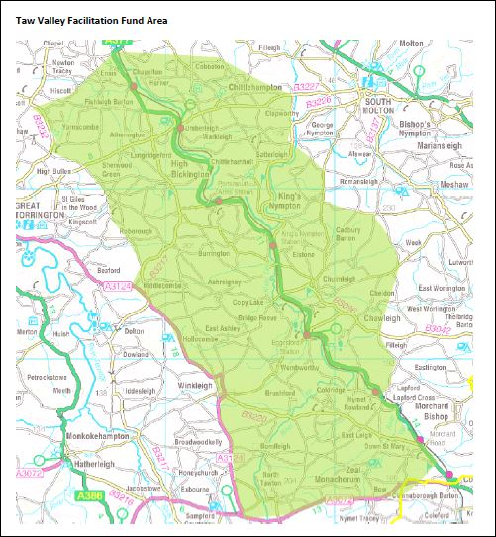
The area covered is from North Tawton to Bishops Tawton along the valley of the River Taw in Devon. The total area is 34,000 Ha, of which woodland is a major feature with deciduous woodlands comprising of 7.4% of the total (2,500 Ha).

The 68 signed up farmers manage 2,354 Ha which includes woodland, culm grasslands, floodplain and grazing marsh and river habitats. The main issues in the area include phosphate and nitrate levels, faecal indicator organisms, flooding and undermanaged woodlands.

Training

Since the start of the project 3 training events have been held- Hedgerow and Boundaries Grant Workshop, Sustainable Intensification Workshop and Riverbank Management Workshop. The grant workshop attracted the greatest numbers with 14 signed up members attending. From this workshop 4 members submitted applications to this grant. The Sustainable Intensification Workshop had a good turnout of 25 people, of which 5 were members of the group. Some lively discussion was held and people went away with a greater understanding of the research currently being carried out.

Engagement

Communication with the group has generally been through e-mail but 17 members do not have e-mail addresses (or, perhaps, have been unwilling to supply them). The Biosphere Reserve website has the main background information and contact details for the group. This has been regularly updated but has not been used as the main promotion of events due to anyone then being able to attend events without being members of the group. A Facebook group has been set up but more promotion of this is needed before it is seen as a valuable tool for engagement.

Steering the Group

A steering group has been set up comprising of four farmer/landowner representatives (dairy, mixed organic, woodland) and members from North Devon Biosphere and Westcountry Rivers Trust. The steering group has met twice.

The full group of were invited to a meeting in Chulmleigh in November 2016 and 19 members attended.

The Future

During the first six months of this project the group has started to know each other better and to work closer together. There are good plans for future events and members are keen to host these. A good relationship has been developed with the many organisations that can help run training events and it is hoped that there will be plenty of collaborative working during the next years.

