Invitation to tender - Marine and Landscape Pioneer short film(s)

Aim: to create an engaging and non-technical short film(s) that will demonstrate the connectivity of the land, coast and people to the sea. To tell the stories of those who live and work in the environment, and help others understand how our activities affect the sea and vice versa. To identify beneficiaries and benefits of the coast and sea using ‘regular’ people’s own words, to inspire other people to action to help protect and enhance it.
Objectives of the short film(s):
- To make people aware of the connectivity of the land and sea, by telling the stories of the people involved
- To make people aware of the benefits of protecting our natural environment
- To inspire and encourage people to engage in activities on the land and the coast that will lead to improved health of the sea
Rationale behind this proposal:
The Pioneer programme came from the Government’s 25 Year Environment Plan, whose overarching aim is to ‘leave the environment in a better condition for future generations’. In North Devon we have 2 pioneers, Landscape and Marine and this provides the opportunity to demonstrate how important the land/sea connection is to us all. To do this, we would like to engage people, those that know little about their natural environment and illustrate what they can contribute to improving our environment, how important it is, and how people benefit from our natural environment – including the little-known benefits.
Following the logic of the diagram below (which was developed by English Heritage, but can be applied to the natural environment), an increase in understanding of the connectivity of the sea to the land will lead to people valuing it and helping to protect and conserve it.

By targeting the local community to showcase the importance and benefits of our land and coast and how they are intrinsically linked the sea, we will be able to promote the work that is being undertaken through the Pioneers in North Devon and encourage participation. It would also be useful if the stories, although about North Devon, were interesting enough to be enjoyed outside North Devon.
Connection to a wider series of short films:

As well as being a standalone film, this film will form part of a series of films being developed by the North Devon pioneer projects. The marine focussed films are being developed through the WWF - UK SEAS project, which forms part of the work of the Marine Pioneer.
The aim of the film series is to highlight the vital connections between river catchments, headwaters, estuaries, coasts and the sea, how activities on land can affect the health of the marine environment, and how the sea impacts on the coast and in turn affects the benefits to people.
We encourage any potential tenderer to also look at the UK SEAS film currently being advertised and consider bidding for both opportunities. However each contract shall be awarded to the most appropriate film maker. If this happens to be separate film makers for each contract, then both film makers will be expected to collaborate to make sure that both sets of films ‘flow’ and provide a narrative.
The WWF UK SEAS film guidance can be found here: http://www.northdevonbiosphere.org.uk/news/celebrating-our-coast-and-sea-filmmakers-we-need-you

Audience
- Primary audience - those that are not yet engaged with their marine environment, with an eye on those that could have an impact (land managers, investors, etc) but needs to be a story not a ‘marketing product’
- Secondary audience - People who already understand the marine environment in North Devon and the benefit it provides, to inspire them to engage with other areas of the Marine and Landscape Pioneers’ work

Narrative
We are open to ideas about how best to approach the subject matter, but our initial idea is to use local people within North Devon to speak about their own experiences and perceptions of the benefits provided by the marine environment. Case studies of people who have worked towards conservation can be provided by contributing organisations, if needed.
It is important that this set of short film/s feels connected to the other set of films, which are being created (by WWF) to form a ‘series’, but that the film/s can also stand alone in their own right
There is an opportunity through the films to look at a range of subjects that demonstrate how people are linked to their natural environment. Examples could include:
- Showing how our natural environment provides services to people and what these are; such as, clean air and water, flood prevention, food, recreation, etc
- How our natural environment can be affected and how it impacts people; climate change, invasive species, species migration, etc
- How people get involved to help improve, monitor or celebrate our natural environment
- Management of land and coast including not only those that do it as a ‘day job’ but those that are stewards and volunteers.
These are just suggestions and the filmmaker is encouraged to think creatively – not all subjects can be addressed but good stories are needed to provide engaging and non-technical films for a wide range of people.

What is required
- An initial workshop held in Devon to develop a more detailed concept for this film/s. This will include:
  - Developing a detailed concept and workplan for the project, e.g. how many films will be produced, their length, approach, dissemination routes, etc. This will involve members of the project steering group and project manager.
  - Develop a concept for how the series of films will fit together. This may involve dialling in colleagues from other organisations involved with the development of the film series.
- A close working relationship with the Project Manager and project Steering Group throughout the duration of the contract to allow flexibility to capitalise on unplanned opportunities.
- Willingness to explore novel approaches to creating the films e.g. working with local film students to parts of the film/s.
Desirable:
- An understanding of the natural environment in North Devon and the people who benefit from it (especially helpful will be any pre-existing relationships with people in North Devon that we could film)

Deliverables
- Short film/s of a sufficient quality for projection, which meet the aim of this contract. It is our intention that the films should be no longer than 5 minutes, although this is negotiable, if a good idea is proposed.
- Clips from the films which can be used on social media to support Marine and Landscape Pioneer project activities – including at least one clip that can be used for the Biosphere #ProudToShare campaign
- Raw material to be made available to the Biosphere Foundation, for continued use by project Partners (see annexe B below)

Budget and timescales
- The maximum budget for this contract is £13, 500 (VAT included)
- The deadline for completion of the film/s is to be decided in the kick off meeting
Project management
- The project will be managed by North Devon Moving Image, hosted by the Biosphere Foundation and guided by the project Steering Group, which has representation from the Biosphere Reserve, Environment Agency, Marine Management Organisation, the National Trust, Natural England, and WWF- UK.
Tender procedure
Please include in your submission:
- how you plan to meet the requirements of this contract, as well as initial concepts for the final films (including ideas of the people who could be filmed). It would be helpful to include a draft skeleton agenda for the workshop.
- Details of who would be involved in this project, including names, job titles and roles and include their C.V.s.
- Examples (links are fine) of previous work that would demonstrate that you are able to meet the aims of this contract.
- Please provide final detailed costs, including budgets for travel and VAT.
- An indication of how long you would require to complete this contract (broken down into milestones if possible)
The contract will be awarded to the filmmaker who has demonstrated:
- Good knowledge of the concept
- Good level of creative thinking to address a complex subject
- Demonstrated that they can meet the aims of the project
- Provide good value for money.
Please email your submissions to: chrissie.ingle@devon.gov.uk by 9th November 2018

Annexe A: The Defra Pioneers:
There are four pioneers that that will be used to test innovative ideas for governance of the environment - to inform the Government’s 25 Year Environment Plan. The four pioneers are:
- Marine Pioneer led nationally by the Marine Management Organisation MMO and delivered locally over two places North Devon, hosted by the North Devon Biosphere Reserve and Suffolk, hosted by Suffolk Coast and Heaths AONB.
- Landscape Pioneer based in the North Devon Biosphere and led by Natural England
- Catchment Pioneer in Cumbria led by the Environment Agency
- Urban Pioneer in Manchester led by the Environment Agency
About the North Devon Marine Pioneer and Landscape Pioneer
The Biosphere's inclusion in two of the Defra Pioneers (Landscape and Marine) is testament to the North Devon Biosphere’s effective partnership working and success in pushing forward projects to improve this area's environment and deliver the associated economic and social benefits.
The North Devon Pioneers will be using the Natural Capital Approach – natural capital consists of the stocks of natural assets (geology, soil, air, water and living things), that provide benefit people.

The pioneers have been developing innovative demonstration projects to test how, realistically, we can leave our environment in a better condition for the next generation. To do this communication is vital to engaging people with their environment, these films will help with that.
The area of the Marine and landscape pioneer can be seen in the map below.
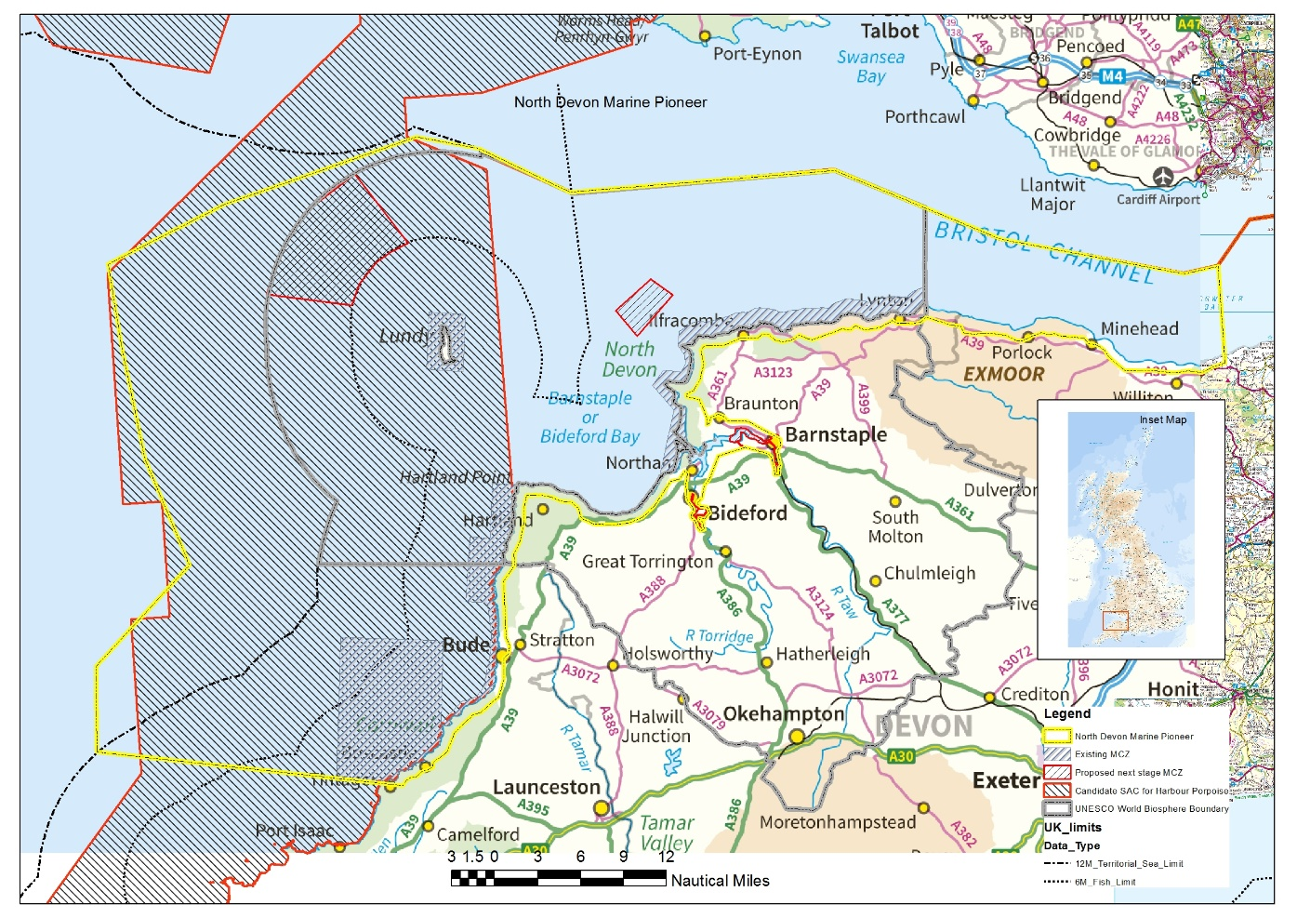
Figure 1The Marine Pioneer area (yellow line) extends beyond the North Devon Biosphere area (grey line) for the purposes of data capture. The Landscape Pioneer is based within the land component of the North Devon Biosphere.
Annexe B: Project funders and partners
North Devon's UNESCO Biosphere Reserve
Reaching to the heights of Dartmoor and Exmoor and via the sea to Lundy, North Devon's Biosphere Reserve is one of 669 Reserves in 120 countries designated by UNESCO's Man and the Biosphere Programme and was the first of 6 to be designated in the UK. All exist to inspire a positive future by connecting people and nature.
Developing partnerships and managing projects for a sustainable future in North Devon, The North Devon Biosphere team work to maintain our world class environment and the high quality of life we get from it. We are here to help and advise, and facilitate partnerships and projects.
North Devon's Biosphere Reserve has:
3 Special Qualities | 3 Functions
- Special landscapes and wildlife areas  - Communities who care about living sustainably  - A rich cultural heritage | - Conservation and Caretaking  - Learning and Research  - Sustainable Development
UNESCO Man and the Biosphere (MAB) is an intergovernmental programme aiming to set a scientific basis for the improvement of relationships between people and their local environments.
Biosphere Reserves are established by individual countries and recognised by UNESCO MAB to promote sustainable development based on local community efforts and sound science.
North Devon Biosphere Foundation - is a not-for-profit company limited by guarantee, registered with ENTRUST as an environmental body. The Foundation is dedicated to furthering the aims of the UNESCO North Devon Biosphere Reserve Partnership.
Partners and Communities in North Devon - The Biosphere is home to about 150,000 people. Our success depends on the strength of the relationships we create. We work together to connect people across disciplines, cultures and borders and to reconnect people to each other and to nature. It’s these powerful connections that mean we can achieve outcomes together that we could not achieve alone and be part of something bigger.
We are all ‘the Biosphere’ working together to create a positive future by connecting people with nature.

The National Trust
The National Trust is a charity founded in 1895 by three people who saw the importance of our nation’s heritage and open spaces and wanted to protect them for everyone to enjoy. More than 120 years later, these values are still at the heart of everything the Trust does. It looks after special places throughout England, Wales and Northern Ireland, including coastline and beaches, forests and other wild habitats, farmland, archaeological remains, nature reserves, and historic buildings. With over 5 million members, the Trust wants more people to access, enjoy and value a healthier and more beautiful natural environment and has set out an ambitious agenda to restore a healthy, beautiful natural environment, and work with partners at landscape scale. The Trust relies on the support of its members, donors and volunteers, as well as income from grant-making bodies and commercial activities such as retail and catering, to look after the places in its care.

In the South West, the Trust cares for 20% of the coastline, with a particular concentration of coastal properties in North Devon. This coastal estate presents opportunities for habitat restoration and creation, extending nature-friendly farming, promoting sustainable coastal adaptation in the face of erosion and sea level rise, and providing engagement and outdoor experiences for visitors to and residents of the area.
Environment Agency
The Environment Agency (EA) was established in 1996 to protect and improve the environment. The EA works to create better places for people and wildlife, and to support sustainable development. The EA is an executive non-departmental public body, sponsored by the Department for Environment, Food & Rural Affairs.
Their priorities are to
- work with businesses and other organisations to manage the use of resources
- increase the resilience of people, property and businesses to the risks of flooding and coastal erosion
- protect and improving water, land and biodiversity
- improve the way we work as a regulator to protect people and the environment and support sustainable growth

To do this they have identified 3 principles in their publication ‘creating a better place our ambition to 2020’ https://bit.ly/2Owg9za
- Put people and wildlife first: our goal is to create a better place for them.
- 80/20: we will focus on the 20% that makes 80% of the difference.
- Support local priorities: every place and community has its own needs.
Natural England
Natural England is the government’s adviser for the natural environment in England, helping to protect England’s nature and landscapes for people to enjoy and for the services they provide. Natural England is an executive non-departmental public body, sponsored by the Department for Environment, Food & Rural Affairs. Natural England is leading the Landscape Pioneer also based in North Devon and within the North Devon Biosphere Reserve.
Within England they are responsible for:
- promoting nature conservation and protecting biodiversity
- conserving and enhancing the landscape
- securing the provision and improvement of facilities for the study, understanding and enjoyment of the natural environment
- promoting access to the countryside and open spaces and encouraging open-air recreation
- contributing in other ways to social and economic well-being through management of the natural environment

The Marine Management Organisation (MMO)
The MMO license, regulate and plan marine activities in the seas around England so that they're carried out in a sustainable way. The MMO is an executive non-departmental public body, sponsored by the Department for Environment, Food & Rural Affairs. To find out more about the MMO please visit their website:
https://www.gov.uk/government/organisations/marine-management-organisation
Annexe C Resources and information:
- North Devon Marine Pioneer: https://www.northdevonbiosphere.org.uk/marinepioneer.html
- Landscape Pioneer: https://www.northdevonbiosphere.org.uk/landscape-pioneer.html
- UK SEAS project https://www.wwf.org.uk/what-we-do/projects/uk-seas-project
- Biosphere #ProudToShare campaign https://bit.ly/2MCbqv7
- This animated film, while not what we are looking for, demonstrates the link from the land to the sea. https://www.youtube.com/watch?v=bSrgPLkvP8Q
- A Green Future: Our 25 Year Plan to Improve the Environment https://assets.publishing.service.gov.uk/government/uploads/system/uploads/attachment_data/file/693158/25-year-environment-plan.pdf

